Group 2
Roll nos. 11 - 20

Advanced Microprocessor Systems
May 2005

1.Explain the display modes of 8279.

There are various options of data display. For example, the command number of characters can be 8 or 16, with each character organised as single 8-bit or dual 4-bit codes. Similarly there are two display formats. The first one is known as left entry mode or type writer mode, since in a typewriter the first character typed appears at the left-most position, while the subsequent characters appear successively to the right of the first one. The other display format is known as right entry mode, or calculator mode, since in a calculator the first character entered appears at the rightmost position and this character is shifted one position left when the next character is entered. Thus all the previously characters are shifted left by one position when a new character is entered.

1)Left Entry Mode: In the left entry mode, the data is entered from the left side of the display unit. Address 0 of the display RAM contains the leftmost display character and address 15 of the RAM contains the right most display character. It is just like writing in our note books, i.e. from left to write. If the 8279 is in autoincrement mode, the display RAM address is automatically updated with successive reads or writes. The first entry is displayed on the leftmost display and the sixteenth entry on the rightmost display. The seventeenth entry is again displayed at the leftmost display position.

2)Right Entry Mode In the right entry mode, the first entry to be displayed is entered on the rightmost display. The next entry is also placed in the right most display but after the previous display is shifted left by one display position. The leftmost character is shifted out of that display at the seventeenth entry and is lost, i.e. it is pushed out of the display RAM.

2. Give the control word format of 8255.

Control Word
The content of control register is control word, which specifies I/O function for each port. All ports are used as either input or output port. This is achieved by programming bits of control word. The register can be accessed to write a control word when A0 and A1 are at logic 1. The register is not accessible for read operation.

Control Word format of 8255
8255 can operate in two modes Input/Output mode and Bit set/Reset Mode. To make the operation possible in either of these modes, we write control words to control register. If bit 7 of the control word is a logical 1 then the 8255 will be configured in I/O mode

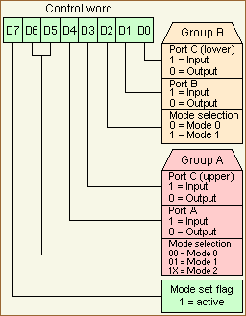

If bit 7 of the control word is a logical 0 then each bit of the port C can be set or reset.
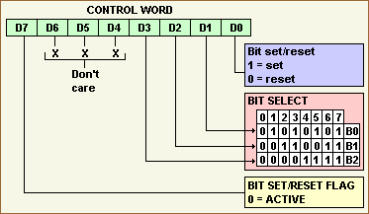

3) Explain the features of a micro controller.
MicroControllers
Microcontroller is a device which contains a microprocessor along with I/O ports and minimum memory in a single package or it is a microprocessor with integrated peripherals. It contains most of the components required to form a microprocessor system, so called a single chip microcomputer. And it also has the ability to do some control functions, so called as a microcontroller.

Block Diagram
Microprocessor
Peripherals like Timer
I/O Ports
ROM/RAM memory

Microcontrollers are primarily used to perform dedicated functions. Generally they include all the essential elements of a computer on a single chip: MPU, R/W memory, ROM and I/O lines. Most of the microcontrollers have an 8-bit word size , at least 64 bytes of R/W memory, and 1KB of ROM. The range of I/O lines vary from 16 to 40 lines.A microcontroller (or MCU) is a computer-on-a-chip. It is a type of microprocessor emphasizing self-sufficiency and cost-effectiveness, in contrast to a general-purpose microprocessor. The only difference being in a microcontroller and a microprocessor is that a microprocessor has three parts - ALU, Control Unit and registers (like memory), but the microcontroller has additional elements like ROM, RAM etc. In contrast to general-purpose CPUs, microcontrollers do not have an address bus or a data bus, because they integrate all the RAM and non-volatile memory on the same chip as the CPU. Because they need fewer pins, the chip can be placed in a much smaller, cheaper package.
A microcontroller is a single integrated circuit, commonly with the following features:
- central processing unit - ranging from small and simple 4-bit processors to sophisticated 32- or 64-bit processors
- input/output interfaces such as serial ports (UARTs)
- other serial communications interfaces like I²C, Serial Peripheral Interface and Controller Area Network for system interconnect
- peripherals such as timers and watchdog
- RAM for data storage
- ROM, EPROM, EEPROM or Flash memory for program storage
- clock generator - often an oscillator for a quartz timing crystal, resonator or RC circuit
- many include analog-to-digital converters

4) Explain How a key debounce can be checked?

When a mechanical push button key is pressed or released, the metal contacts of the key momentarily bounce before giving a steady state reading. Therefore it is necessary that the bouncing of the key should not be read as an input. The key bounce can be eliminated from input data by the key debounce technique, using either hardware or software.
In this circuit the outputs of the NAND gates do not change even if the key is released from position A1. the outputs change when the key makes a contact with position B1. when the key is connected to A1, A1 goes low. If one of the outputs to gate G1 is low , the output O1 becomes 1, which makes B2 high. Because line B1 is already high the output of O2 goes low which makes A2 low. When the key connection is released from A1 it goes high. But because A2 is low the output does not change. When the key makes contact with B1 the outputs change. This means when the key goes from one contact(+5V) to another contact(ground), the output does not change during the transition period, thus eliminating multiple readings.

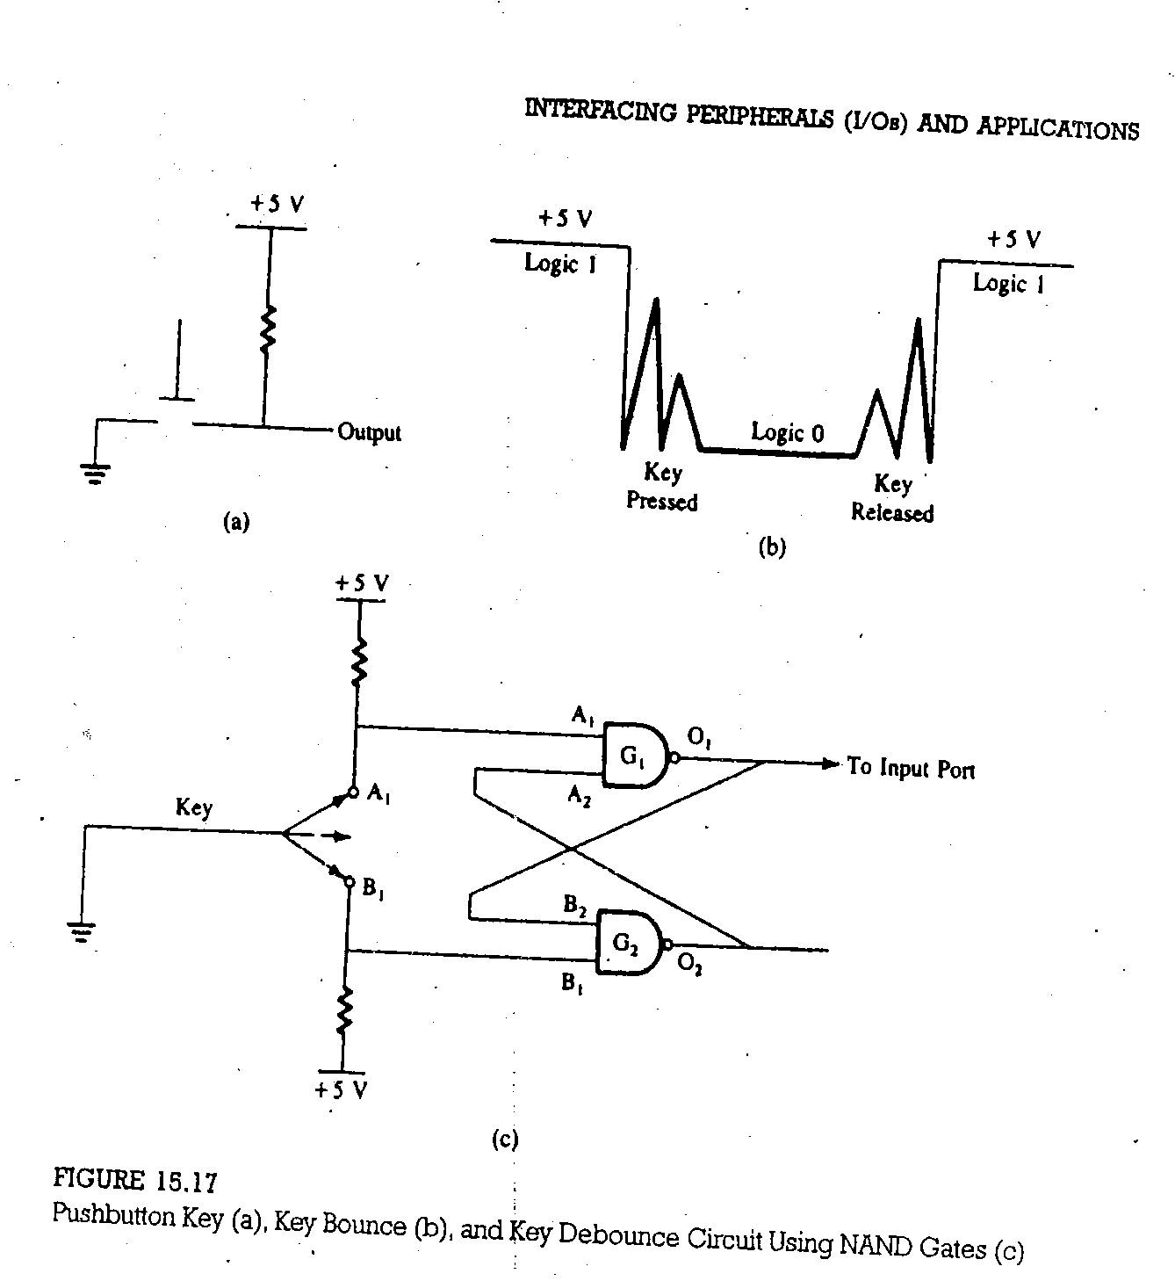

5) How is physical address generated from effective address?
The complete physical address which is 20 bits long is generated using the segment and offset registers, each 16-bits long of the 8086 microprocessor.
For generating a physical address from contents of these two registers, the content of a segment register also called as segment address is shifted left bit-wise 4 times and to this result, content of an offset register also called as offset address is added, to produce a 20-bit physical address. For eg:
Segment address : 1005H
Offset address : 5555H
Segment address: 0001 0000 0000 0101
After shifting: 0001 0000 0000 0101 0000
Offset address: + 0101 0101 0101 0101
Physical address: 0001 0101 0101 1010 0101
1 5 5 A 5
Thus, the segment addressed by the segment value 1005H can have offset values from 0000H to FFFFH within it, ie max 64k loc may be accommodated in the segment.
In this way the physical address is calculated from the effective address.
6) What is a stack register? How can it be initialized?

The four segment registers (CS, DS, ES, and SS) are used to "point" at location 0 (the base address) of each segment. The segment registers are only 16 bits wide, but the memory address is 20 bits wide. The BIU takes care of this problem by appending four 0's to the low-order bits of the segment register. In effect, this multiplies the segment register contents by 16.
The stack is a section of memory set aside to store addresses and data while a sub program executes. The SS register is used to hold the upper 16-bits of the starting address for the program stack.
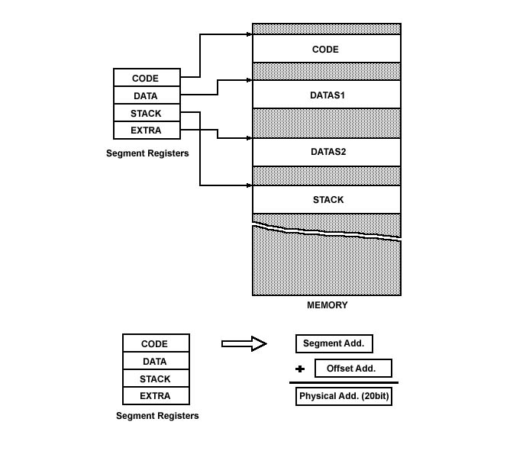
The stack segment is that segment of memory which is used to store stack data.the CPU uses the stack for temperorily storing important data,e g the contents of CPU registers. The stack grows down, ie data is pushed onto the stack in the memory locations with decreasing addresses.when information is required by CPU ,they will be popped out from stack.
The upper 16-bits of the starting address for stack segment are kept in the stack segment register. The stack pointer register (SP) in the EU holds the 16 bit offset from the start of the segment to the memory location where a word was most recently stored on the stack (that position is termed as top of the stack). The physical address of the stack is represented as SS:SP

7) What are the logical instructions available for 8086?
Logical Instructions
NOT- Logical NOT of byte or word (one's complement)
AND -Logical AND of byte or word
OR -Logical OR of byte or word
XOR- Logical exclusive-OR of byte or word
TEST- Test byte or word (AND without storing)

These type of instructions are used for carrying out the bit by bit shift, rotate, or basic logical operations. All the condition code flags are affected depending upon the result. Basic logical operations available with 8086 instruction set are AND, OR, NOT, and XOR. The instruction for each of these operations are discussed as follows.

AND
This instruction bit by bit ANDs the source operand that may be an immediate, A register or a memory location. The result is stored in to the destination operand that may be a register or a memory location.
The result is stored in the destination operand. At least one of the operands should be a register or a memory operand. Both the operands cannot be memory locations or immediate operands. An immediate
operand cannot be a destination operand.
OR
The OR instruction carries out the OR operation in the same way as described in case of the AND operation.
. The limitations on source and destination operands are also the same

TEST
Performs a bit by bit logical AND on the two operands. Each bi of result is then set to 1,if corresponding bits of both operands are 1, else result bit is reset to 0. Flags are affected.

8) Give the Functions of following instructions
i.) POPF: Pop Flags from Stack
The POPF instruction loads the flag register completely from the word contents of the memory location currently addressed by SP and SS. The SP is incremented by two for each POP operation.
ii)LEA: Load Effective Address
The instruction LEA loads the offset in of an operand in the specified register.
For example, LEA BX, [BX + SI + DISP]
Note that memory is not involved in this, just address arithmetic.
iii)SCAS :Scan String (Byte, Word or Doubleword)

Usage: SCAS string
SCASB
SCASW
SCASD (386+)
Modifies flags: AF CF OF PF SF ZF

Compares value at ES:DI (even if operand is specified) from the accumulator and sets the flags similar to a subtraction. DI is incremented/decremented based on the instruction format (or operand size) and the state of the Direction Flag.

iv)LOOP: Loop unconditionally: This instruction executes the part of the program from the label or address specified in the instruction upto the loop instruction, CX number of times. The following sequence explains the execution. At each iteration, CX is decremented automatically. In other words, this instruction implements DECREMENT COUNTER and JUMP IF NOT ZERO structure.

Eg: MOV CX,0005
MOV BX,0FF7H
Label: MOV AX,CODE1
OR BX,AX
AND DX,AX
Loop Label

9) How a processor can function in virtual mode? Explain.

In a programmer’s view, there exists a large memory space which is not actually present in the system memory. Although the processor may have only 16MB of physical memory, large application programs, requiring more memory can be executed using the available memory by dividing it into smaller segments. Thus to the user there exists a very large logical memory space which is not actually available. As the name suggests, virtual memory does not exist physically in a system. It is however possible to map a large virtual memory space onto the real physical memory.

10)Give the features of RISC processor.

RISC, or Reduced Instruction Set Computer. is a type of microprocessor architecture that utilizes a small, highly-optimized set of instructions, rather than a more specialized set of instructions often found in other types of architectures.
The first RISC projects came from IBM, Stanford, and UC-Berkeley in the late 70s and early 80s. The IBM 801, Stanford MIPS, and Berkeley RISC 1 and 2 were all designed with a similar philosophy which has become known as RISC. Certain design features have been characteristic of most RISC processors:
1. one cycle execution time: RISC processors have a CPI (clock per instruction) of one cycle. This is due to the optimization of each instruction on the CPU and a technique called ;
2. pipelining: a technique that allows for simultaneous execution of parts, or stages, of instructions to more efficiently process instructions;
3. large number of registers: the RISC design philosophy generally incorporates a larger number of registers to prevent in large amounts of interactions with memory
RISC Processors
As the processor technology began to evolve, the trend was to add more and more instruction capability to the processor. As a consequence, the control unit & decoding unit became very complex. In some processors, the control unit occupies 50-605 of chip area that reduce the space available to registers. And also the memory access instruction tends to slow down the execution.
RISC uses small set of frequently used instructions , thus simplifying the hardware design and improving the processor performance.
Features
Number of instructions is minimized.
Number of addressing modes is relatively few.
Number of memory reference instructions is minimized. Memory is accessed using load and store instructions.
Processing is register intensive. Many more registers( 32 to 100) are included and most of the computing is performed using registers rather than memory.
Instruction format is simplified and each instruction is executed in one cycle.
Simple instruction decoder.
11) Discuss the organization and architecture of 8255 with Block diagram.

The parallel input-output port chip 8255 is also known as programmable peripheral input-output port. The intel’s 8255 is designed for the use with intel’s 8-bit, 16- bit and higher capability microprocessors.
The features are:
3 8-bit IO ports PA, PB, PC
PA can be set for Modes 0, 1, 2. PB for 0,1 and PC for mode 0 and for BSR. Modes 1 and 2 are interrupt driven.
PC has 2 4-bit parts: PC upper (PCU) and PC lower (PCL), each can be set independently for I or O. Each PC bit can be set/reset individually in BSR mode.
PA and PCU are Group A (GA) and PB and PCL are Group B (GB)
Address/data bus must be externally demux'd.
TTL compatible.
Improved dc driving capability

It has a 40 pins of 4 groups.
1. Data bus buffer
2. Read Write control logic
3. Group A and Group B controls
4. Port A, B and C

Data bus buffer: This is a tristate bidirectional buffer used to interface the 8255 to system databus. Data is transmitted or received by the buffer on execution of
input or output instruction by the CPU.
• Control word and status information are also transferred through this unit.
Read/Write control logic: This unit accepts control signals ( RD, WR ) and also inputs from address bus and issues commands to individual group of control blocks ( Group A, Group B).
• It has the following pins.
a) CS – Chipselect : A low on this PIN enables the communication between CPU and 8255.
b) RD (Read) – A low on this pin enables the CPU to read the data in the ports or the status word through data bus buffer.
c)WR ( Write ) : A low on this pin, the CPU can write data on to the ports or on to the control register through the data bus buffer.
d) RESET: A high on this pin clears the control register and all ports are set to the input mode
e) A0 and A1 ( Address pins ): These pins in conjunction with RD and WR pins control the selection of one of the 3 ports.
Group A and Group B controls : These block receive control from the CPU and issues commands to their respective ports.
•Group A - PA and PCU ( PC7 –PC4)
• Group B - PCL ( PC3 – PC0)
• Control word register can only be written into no read operation of the CW register is allowed.
a) Port A: This has an 8 bit latched/buffered O/P and 8 bit input latch. It can be programmed in 3 modes – mode 0, mode 1, mode 2.
b) Port B: This has an 8 bit latched / buffered O/P and 8 bit input latch. It can be programmed in mode 0, mode1.
c) Port C : This has an 8 bit latched input buffer and 8 bit out put latched/buffer. This port can be divided into two 4 bit ports and can be used as control signals for port A and
port B. it can be programmed in mode 0.

This can be briefed as:
It has 24 input/output lines which may be individually programmed in 2 groups of 12 lines each, or 3 groups of 8 lines. The 2 groups of input/output pins are named as group A and group B. each of these groups contain a subgroup of 8 input/output lines called as 8 bit port and another subgroup of 4 i/o lines or a 4 bit port. Thus group A contains an 8 bit port A along with a 4bit port A along with a 4 bit port, C upper. The port A lines are identified by symbols PA0-PA7 while the port C lines are identified asnPC4- PC7. similarly group B contains an 8 bit port B, containing lines PB0-PB7 and a 4 bit port C with lower bits PC0-PC3. the port C upper and port C lower can be used in combination as an 8 bit portC. Both the port Cs are assigned the same address. Thus one may have either three 8 bit i/o ports or two 8 bit and 2 4 bit i/o ports from 8255. all of these ports can function independently either as input or as output ports. This can be achieved by programming the bits of an internal register of 8255 called as control word register ( CWR ).

The internal block diagram and the pin configuration of 8255 are shown in fig.
The 8-bit data bus buffer is controlled by the read/write control logic. The read/write control logic manages all of the internal and external transfers of both data and control
words. RD, WR, A1, A0 and RESET are the inputs provided by the microprocessor to the READ/ WRITE control logic of 8255. The 8-bit, 3-state bidirectional buffer is used to
interface the 8255 internal data bus with the external system data bus. This buffer receives or transmits data upon the execution of input or output instructions by the microprocessor. The control words or status information is also transferred
through the buffer.

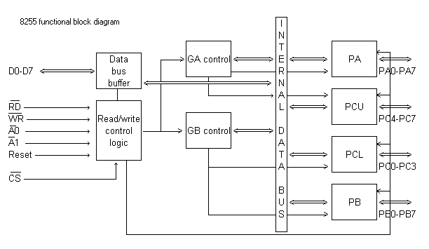

12) (a) Give the internal architecture of 8279 and explain the functions of each block.

(b) Explain the necessity of display RAM in 8279

-A programmable keyboard and display interfacing chip.
-Scans and encodes up to a 64-key keyboard.
-Controls up to a 16-digit numerical display.
-Keyboard has a built-in FIFO 8 character buffer.
The display is controlled from an internal 16x8 RAM that stores the coded display information.
Keyboards consist of a large matrix of keys, all of which are monitored by an on-board processor called the "keyboard encoder". The specific processor varies from keyboard-to-keyboard but they all basically do the same thing: Monitor which key(s) are being pressed/released and send the appropriate data to the host. This processor takes care of all the debouncing and buffers any data in its 16-byte buffer, if needed.
Motherboard contains a "keyboard controller" that is in charge of decoding all of the data received from the keyboard and informs software of what's going on.

a) Pinout Definition of 8279
A0: Selects data (0) or control/status (1) for reads and writes between micro and 8279.
BD: Output that blanks the displays.
CLK: Used internally for timing. Max is 3 MHz.
CN/ST: Control/strobe, connected to the control key on the keyboard.
CS: Chip select that enables programming, reading the keyboard, etc.
DB7-DB0: Consists of bidirectional pins that connect to data bus on micro.
IRQ: Interrupt request, becomes 1 when a key is pressed, data is available.
OUT A3-A0/B3-B0: Outputs that sends data to the most significant/least significant nibble of display.
RD(WR): Connects to micro's IORC or RD signal, reads data/status registers.
RESET: Connects to system RESET.
RL7-RL0: Return lines are inputs used to sense key depression in the keyboard matrix.
Shift: Shift connects to Shift key on keyboard.
SL3-SL0: Scan line outputs scan both the keyboard and displays

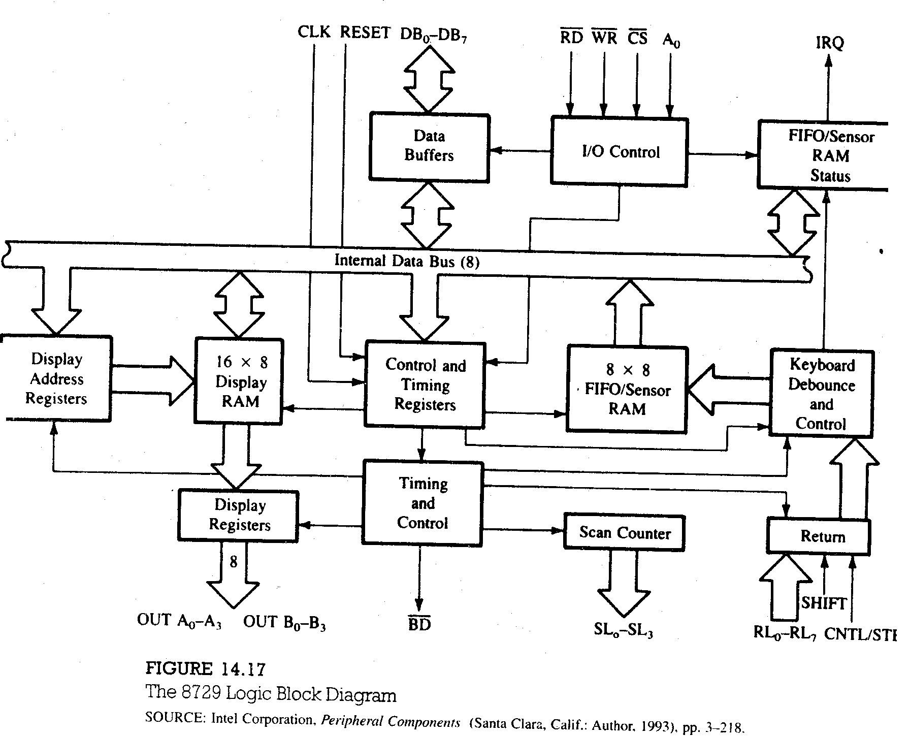

The functional block diagram of 8279

It has four major sections
-Keyboard
-Scan
-Display
-CPU Interface

Keyboard section consists of eight return lines RL0-RL7, that can be used to form the columns of a keyboard matrix. It has two additional inputs shift and control/strobe. The keys are automatically debounce. It also has a 8X8 FIFO RAM. It can store 8 keycodes. The status of the shift and control key are also stored along with keycode. 8279 generates an interrupt signal when there is an entry on FIFO.

Display section has eight output lines divided into two groups A0-A3 and B0-B3. The output lines are connected to the anodes through driver transistor in case of common cathode 7 segment LED. The display can be blanked by BD line. The display section consists of 16X 8 display RAM which can also be organized into dual 16X4. The CPU load the display codes in this RAM.

Scan section has a scan counter and four scan lines, SL0-SL3. The scan lines are used to form the rows of a matrix keyboard and the digit drivers of a multiplexed display.
CPU interface takes care of data transfer between 8279 and the processor. This section has eight bi-directional data lines DB0-DB7 for data transfer.

When a key is pressed it bounces for a short time. If a key code is generated immediately after sensing a key actuation, then the processor will generate the same keycode a number of times. A key typically bounces for 10 to 20 ms. Hence the processor has to wait for the key bounces to settle before reading the keycode.
b)
Display section has eight output lines divided into two groups A0-A3 and B0-B3. The output lines are connected to the anodes through driver transistor in case of common cathode 7 segment LED. The display can be blanked by BD line. The display section consists of 16X 8 display RAM which can also be organized into dual 16X4. The CPU load the display codes in this RAM.

13)a) Give the procedure for interfacing a matrix keyboard with 8085.

Interfacing a matrix keyboard with 8085

A matrix keyboard is where there are more than eight keys. A keyboard with 16 keys can be arranged in a 4 x 4 matrix. It requires eight lines from the microprocessor to make all the connections. When a key is pressed, it shorts one row and column. The interfacing of a matrix keyboard requires two ports: one output port and one input port. Rows are connected to the output port and the columns are connected to the input port.

- Ground all the rows by sending logic 0 through the output port.
- Check the columns by reading the input port. If no key is pressed, all columns remain high. Continue the above two steps until the reading indicates a change
- When one of the keys is pressed, the corresponding column goes low; identify and encode the key

The columns and rows make contact only when a key is pressed. Otherwise it remains high. When the key is pressed, the intersection of row and column must change from high to low. The column lines of the keyboard are connected to the return lines, RL0-RL7 of 8279. As a low is put on each row, the 8279 checks these return lines one at a time to see any of them is low. If it finds any of return lines low, indicating a keypress, it waits a debounce time of about 10.3 ms and checks again. If keypress is still present, the 8279 produces an 8-bit code to represent the pressed key. After sending the packet information of pressed key, it stores the byte in an internal FIFO RAM. IT also asserts the IRQ pin high and increment the FIFO count in the internal status register.

Scan Codes

The keyboard's processor spends most of its time "scanning", or monitoring, the matrix of keys. If it finds that any key is being pressed, released, or held down, the keyboard will send a packet of information known as a "scan code" to the computer.
There are two different types of scan codes: "make codes" and "break codes". A make code is sent when a key is pressed or held down. A break code is sent when a key is released. Every key is assigned its own unique make code and break code so the host can determine exactly what happened to which key by looking at a single scan code. The make code only represents a key on a keyboard--it does not represent the character printed on that key. This means that there is no defined relationship between a make code and an ASCII code. It's up to the host to translate scan codes to characters or commands.

b) Explain the features of DAC.

- DAC requires three elements – resistor network with appropriate weighting, switches and a reference source.
- The output can be a current signal or converted into a voltage signal using an operational amplifier.
- The time required for conversion, called settling time, is dependent on the response time of the switches and the output amplifier.

14) (a) Give a detailed procedure for interfacing a seven segment display with 8085 using 8255.
b) Explain the procedure for interfacing ADC with 8085 using status check method.
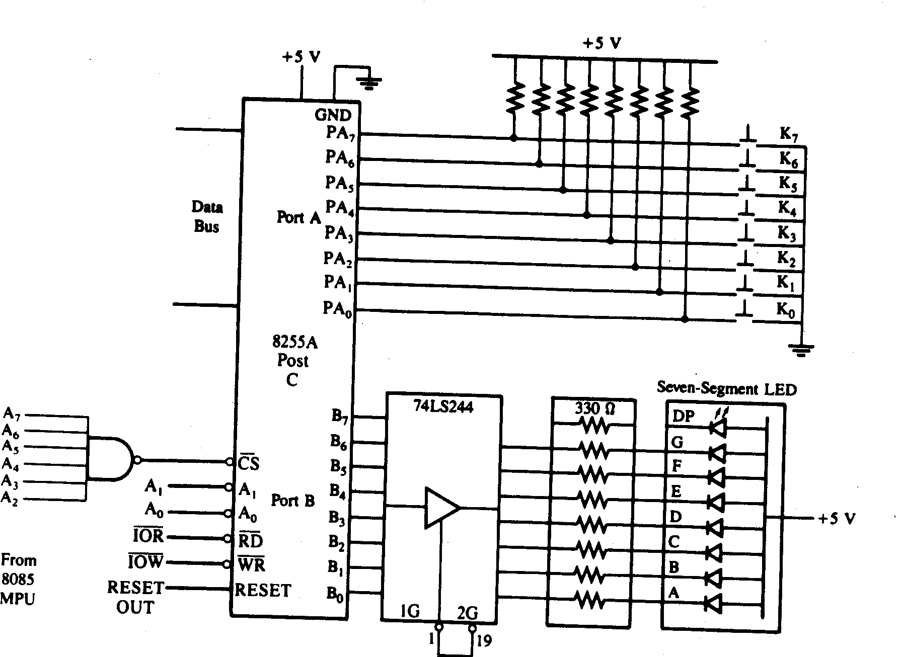

When a key is pressed, the binary reading of the key has no relationship to what it represents. Similarly to display a number at a seven segment LED, the binary value of the number needs to be converted into the seven segment code.
The keyboard and display device can be connected to 8085 through the interfacing device 8255. The 8255 has three ports A, B and C. Here in simple I/O mode, the pushbutton keyboard is connected to Port A as an input port and seven segment LED is connected to Port B as an output port. The ports address range from FCH to FFH. When a push button key is pressed, it bounces (makes & breaks contact) a few times before it makes a firm contact. To prevent multiple readings of the same key, it is necessary to debounce the key. The hardware solution to this problem is to use a key debounce circuit and the software solution is to wait for 10 to 20ms until the key is settled and check the key again.
The display circuit is connected to the Port B of 8255A. To display a digit, it is necessary to convert it into appropriate seven segment code of the LED. The appropriate binary code can be obtained from the look table stored in memory location.
The programming of tis can be divided into following categories:
check if a key is pressed
debounce the key
identify and encode the key in appropriate binary format
obtain the seven segment code and display it.

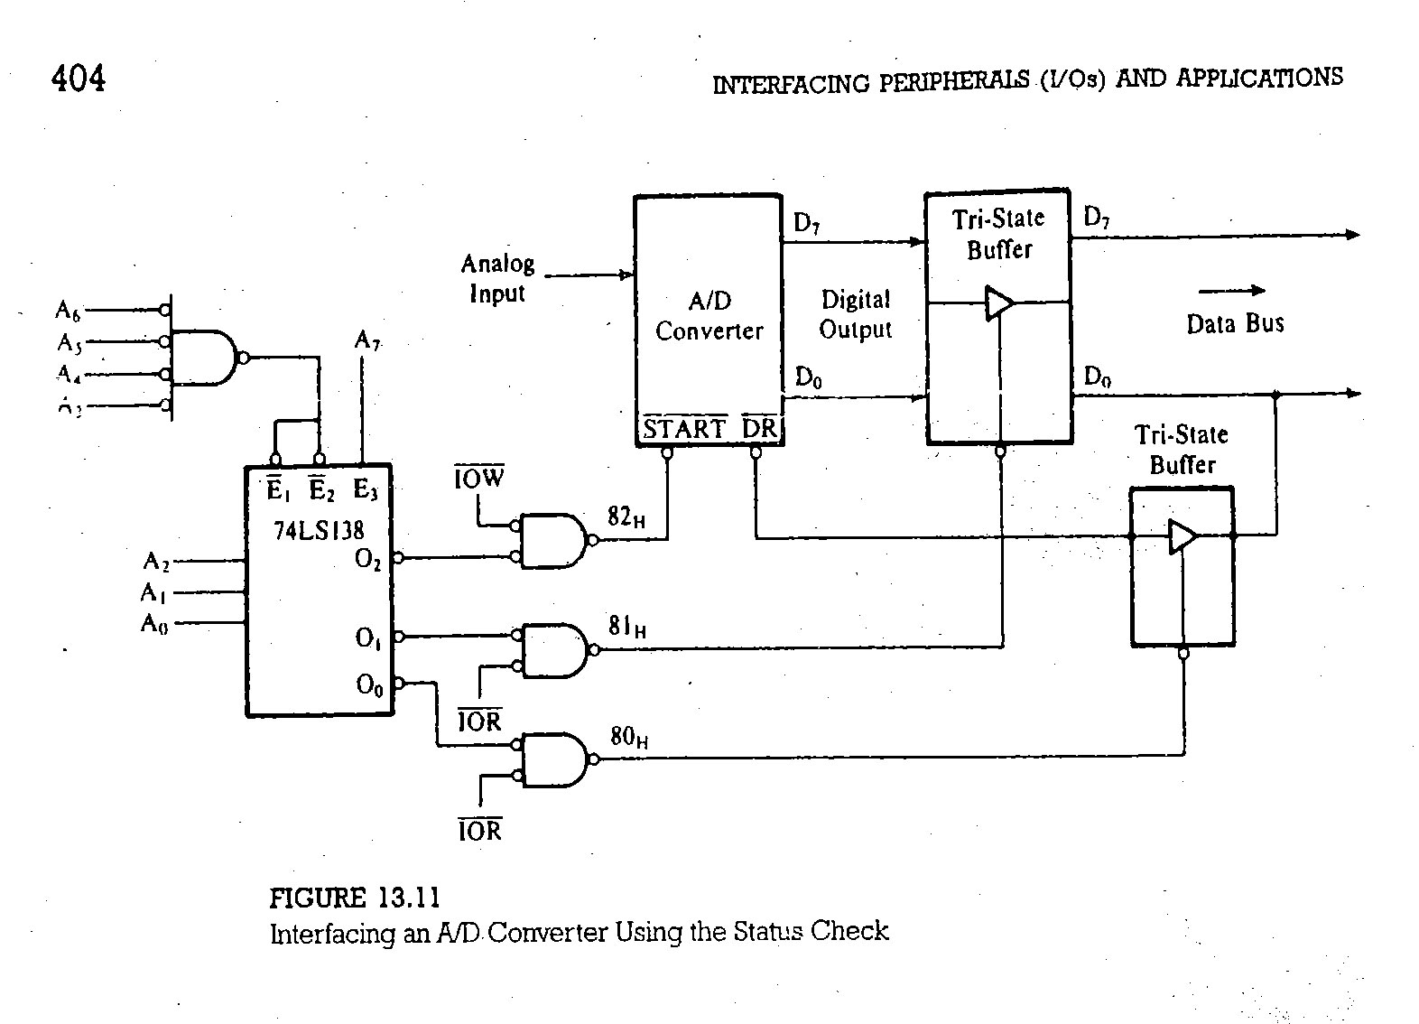
The A/D convertor has one input line for analog signal and eight output lines for converted digital signals. typically the analog signal range from 0 to 10V or +-5V.in addition the converter shows two lines START(active low) and DR(active low). When an active low pulse is sent to START pin, the DA goes high and the output lines goto high impedance state. The rising edge of the start pulse initiates he conversion when the conversion is complete the R goes low and the data are made available on the output lines that can be read by the microprocessor to interface this converter we need output port to send a start pulse and two input ports one to check the status and other to read the output of the converter. The address decoding is performed by using the 3-8 decoder, the 4 input NAND gate and inverters. Three output lines of the decoder are combined with appropriate control signals IOW and IOR(both active low) to assign three port addresses from 80H to 82H. the output port 82H is used to sent a START pulse by writing the OUT instruction. In this case, we are interested in getting a pulse from the microprocessor, and the contents of the accumulator are irrelevant to start the conversion. However ,for some converters the IOW pulse from the microprocessor may not be long enough to start the conversion. When the conversion begins the DR (data ready) goes high and stays high until the conversion is completed. the status of the DR line is monitored by connecting the line to bit D0 of the data bus through a tristate buffer with the input port address 80H. the processor will continue to read port 80H until bit D0 goes low. when the DR goes active the data are available on the output lines of the converter and the processor can access the data by reading the input port 81H.

15) (a) Give internal architecture of 8086.
(b) What is the necessity of instruction queue.
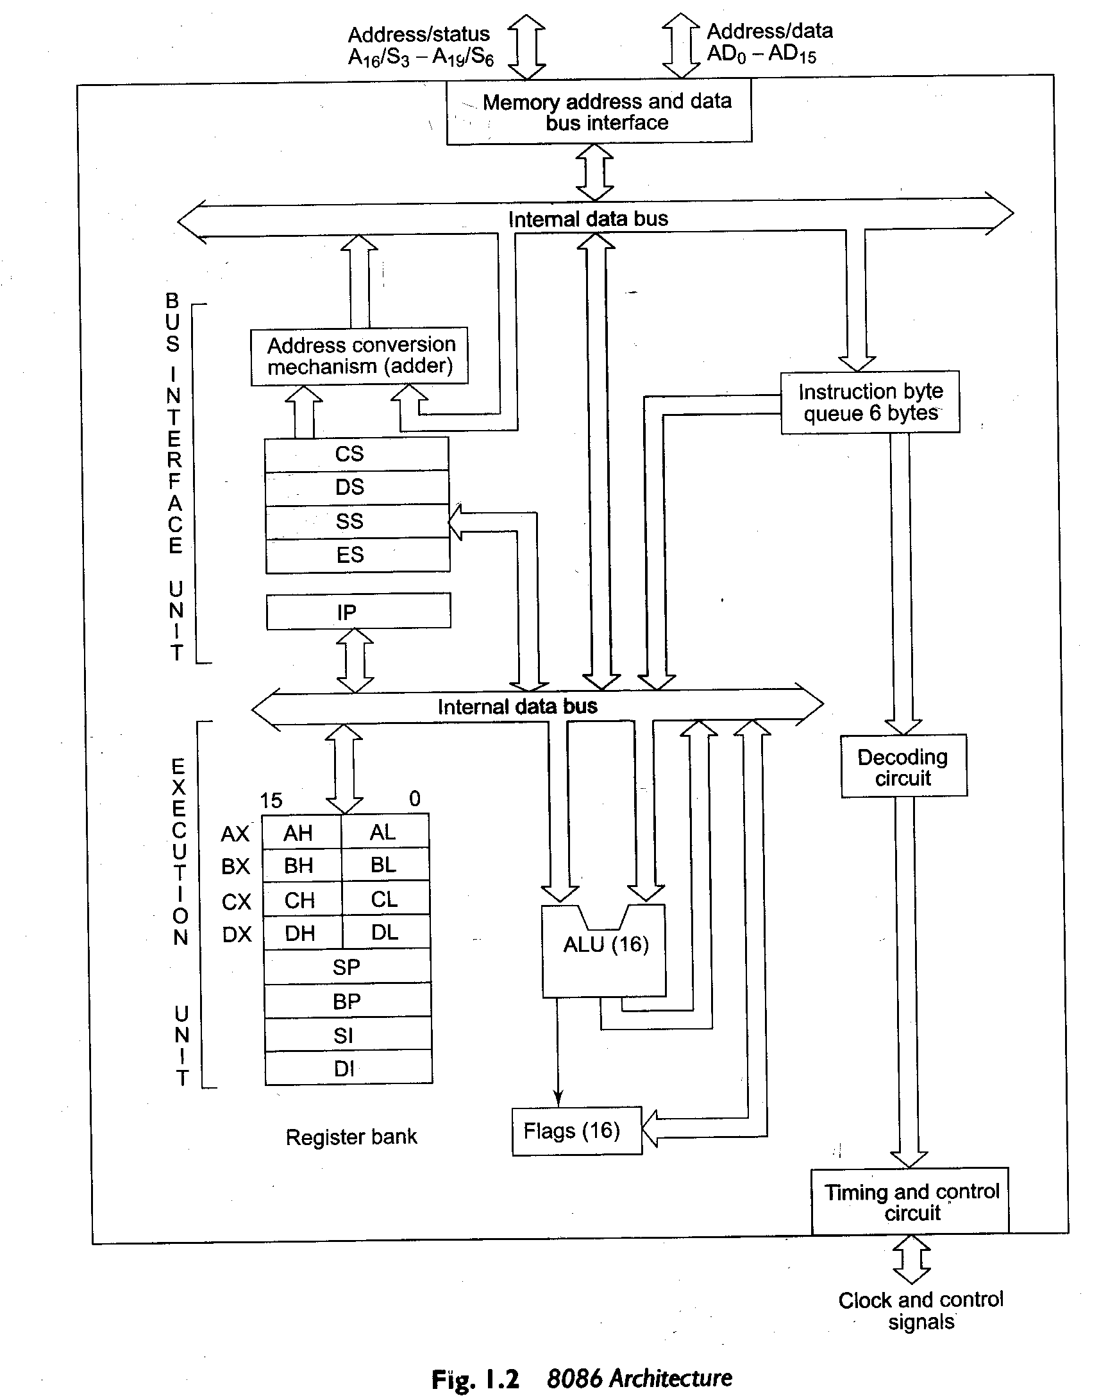

The complete architecture of 8086 can be divided into to parts a)Bus interface unit & b)Execution unit. The BIU contains the circuit for physical address calculations and a predecoding instructionbyte queue (6 bytes long). The bus interface unit makes the system's bus signals available for external interfacing of the devices. In other words, this unit is responsible for establishing communications with external devices and peripherals including memory via the bus. As already stated, the 8086 addresses a segmented memory. The complete physical address which is 20-bits long is generated using segment and offset registers, each 16-bitslong.
For generating a physical address from contents of these two registers, the content of a segment
register also called as segment address is shifted left bit-wise four times and to this result, content of an
offset register also called as offset address is added, to produce a 20-bit physical address.
Thus maximum 64K locations may be accommodated in a segment. Thus, the segment
register indicates the base address of a particular segment, while the offset indicates the distance of the
required memory location in the segment from the base address. Since the offset is a 16-bit number,
each segment can have a maximum of 64K locations. The bus interface unit has a separate adder to
perform this procedure for obtaining a physical address while addressing memory. The segment address
value is to be taken from an appropriate segment register depending upon whether code, data or stack
are to be accessed, while the offset may be the content of IP, BX, SI, DS, SP, BP or an immediate 16-bit
value, depending upon the addressing mode.
In case of 8085, once the opcode is fetched and decoded, the external bus remains free for some
time, while the processor internally executes the instruction. This time slot is utilized in 8086 to achieve
the overlapped fetch and execution cycles. While the fetched instruction is executed internally, the
external bus is used to fetch the machine code of the next instruction and arrange it in a queue known
as predecoded instruction byte queue. It is a 6 bytes long, first-in first-out structure. The instructions
from the queue are taken for decoding sequentially. Once a byte is decoded, the queue is rearranged by
pushing it out and the queue status is checked for the possibility of the next opcode fetch cycle. While
the opcode is fetched by the Bus Interface Unit (BIU), the Execution Unit (Ell) executes the previously
decoded instruction concurrently. The BIU along with the Execution Unit (EU) thus forms a pipeline.
The bus interface unit, thus manages the complete interface of execution unit with memory and I/O
devices, of course, under the control of the timing and control unit.
The execution unit contains the register set of 8086 except segment registers and IP. It has a 16-bit
ALU, able to perform arithmetic and logic operations. The 16-bit flag register reflects the results of
execution by the ALD. The decoding unit decodes the opcode bytes issued from the instruction byte
queue. The timing and control unit derives the necessary control signals to execute the instruction opcode received from the queue, depending upon the info made availability by the decoding circuit. The execution unit may pass the results to the bus interface unit for storing them in memory.

b)In case of 8085, once the opcode is fetched and decoded, the external bus remains free for some
time, while the processor internally executes the instruction. This time slot is utilized in 8086 to achieve
the overlapped fetch and execution cycles. While the fetched instruction is executed internally, the
external bus is used to fetch the machine code of the next instruction and arrange it in a queue known
as predecoded instruction byte queue. It is a 6 bytes long, first-in first-out structure. The instructions
from the queue are taken for decoding sequentially. Once a byte is decoded, the queue is rearranged by
pushing it out and the queue status is checked for the possibility of the next opcode fetch cycle.
Using this technique the processor was made much faster than its predecessor.

16.With the help of examples explain the various addressing modes of 8086.

Addressing modes
Addressing modes indicate a way of locating data or operands. An addressing mode specifies how to calculate the effective memory address of an operand by using information held in registers and/or constants contained within a machine instruction. It describes the type of operands and the way they are accessed for execution of an instruction.
1) Direct (Displacement only) Addressing Mode
The most common addressing mode is the displacement-only (or direct) addressing mode. In this addressing mode, a 16-bit memory address (offset) is directly specified as part of the instruction..

The instruction MOV AL, DS:[8088H] loads the AL register with a copy of the byte at memory location 8088H. Likewise, the instruction MOV [1234H], DS:DL stores the value in the DL register to memory location 1234H.
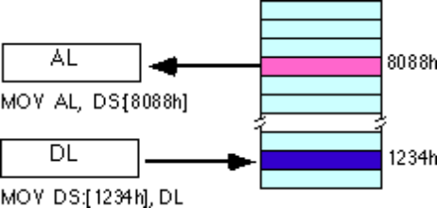
The displacement-only addressing mode is perfect for accessing simple variables.
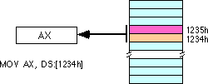
By default, all displacement-only values provide offsets into the data segment. If we want to provide an offset into a different segment, we must use a segment override prefix before the address. For example, to access location 1234H in the extra segment (ES) we would use an instruction of the form MOV AX, ES:[1234H]. Likewise, to access this location in the code segment we would use the instruction MOV AX, CS:[1234H]. The DS: prefix in the previous examples is not a segment override.
2)Immediate addressing mode
In this type of addressing, immediate data is a part of instruction, and appears in the form of successive byte or bytes.
Eg: MOV AX,0005H
Here 0005H is an immediate data. The data can be 8 bit or 16 bit.
3)Register addressing mode
In register addressing mode, the data is stored in a register and it is referred using the particular register. All the registers, except IP can be used for this purpose.
Eg: MOV AX, BX
4) The Register Indirect Addressing Modes
Sometimes, the address of the memory location that contains data or operand is determined by in an indirect way using the offset registers. This mode of addressing mode is known as register indirect addressing mode. Here, the offset address of data is in either BX or SI or DI
There are four forms of this addressing mode on the 8086, best demonstrated by the following instructions:
mov al, [bx]
mov al, [bp]
mov al, [si]
mov al, [di]
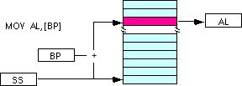
5)Indexed Addressing Modes
In this mode of addressing, offset of the operand is stored in one of the index registers. DS and ES are the default segments for index registers SI and DI respectively.
The indexed addressing modes use the following syntax:
mov al, disp[bx]
mov al, disp[bp]
mov al, disp[si]
mov al, disp[di]
If bx contains 1000h, then the instruction mov cl,20h[bx] will load cl from memory location ds:1020h. Likewise, if bp contains 2020h, mov dh,1000h[bp] will load dh from location ss:3020.
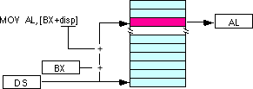

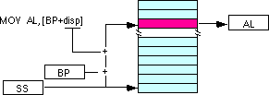
We may substitute si or di in the figure above to obtain the [si+disp] and [di+disp] addressing modes.
6) Register Relative
In this addressing mode, the data is available at an effective address formed by adding an 8-bit or 16-bit displacement with the content of any one of the registers BX, BP, SI and DI. in the default segment.
Eg: MOV AX, 50H[BX]
The effective address is given as 10H * DS + 50H + [BX]
7) Based Indexed Addressing Modes
The based indexed addressing modes are simply combinations of the register indirect addressing modes. The effective address is calculated by adding the content of base register (bx or bp) to the content of an index register (si or di).
Eg: MOV AX, [BX] [SI]
Effective address is computed as 10H * DS + [BX] + [SI]
The allowable forms for these addressing modes are
mov al, [bx][si]
mov al, [bx][di]
mov al, [bp][si]
mov al, [bp][di]
Suppose that bx contains 1000h and si contains 880h. Then the instruction
mov al,[bx][si]
would load al from location DS:1880h. Likewise, if bp contains 1598h and di contains 1004, mov ax,[bp+di] will load the 16 bits in ax from locations SS:259C and SS:259D.
The addressing modes that do not involve bp use the data segment by default. Those that have bp as an operand use the stack segment by default.
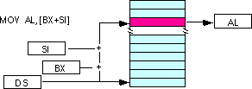
By substituting di in the figure above, we can obtain the [bx+di] addressing mode.
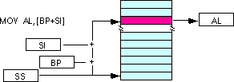
We substitute di in the figure above for the [bp+di] addressing mode.

8) Based Indexed Plus Displacement Addressing Mode
These addressing modes are a slight modification of the base/indexed addressing modes with the addition of an eight bit or sixteen bit constant. The following are some examples of these addressing modes:
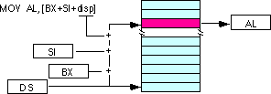
mov al, disp[bx][si]
mov al, disp[bx+di]
mov al, [bp+si+disp]
mov al, [bp][di][disp]
di may be substituted in the figure above to produce the [bx+di+disp] addressing mode.
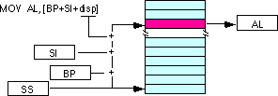
Suppose bp contains 1000h, bx contains 2000h, si contains 120h, and di contains 5. Then mov al,10h[bx+si] loads al from address DS:2130; mov ch,125h[bp+di] loads ch from location SS:112A; and mov bx,cs:2[bx][di] loads bx from location
CS:2007.

Intrasegment direct
Intrasegment
Modes for control Intrasegment Indirect
Transfer instructions Intersegment Direct
Intersegment

Intersegment Direct 9)Intrasegment Direct Mode
In this mode, the address to which the control is to be transferred lies in the same segment in which the control transfer instruction lies and appears directly in the instruction as an immediate displacement value. In this mode, the displacement is computed relative to the content of the instruction pointer IP.
The effective address to which control is transferred is given by the sum of 8 or 16 bit displacement and current content of IP. In case of jump instruction, if the signed displacement (d) is of 8 bits (-128<d<+128), we term it as short jump and if it is of 16 bits, it is termed as long jump.
10)Intra segment Direct Mode
In this mode the displacement to which the control is to be transferred is in the same segment in which the control transfer instruction lies, but it is passed to the instruction indirectly. Here, the branch instruction is found as the content of register or a memory location. This addressing mode may be used in unconditional branch instructions.
11)Intersegment Direct Mode
In this mode, the address to which the control is to be transferred is in a different segment. The addressing mode provides a means of branching from one code segment to another code segment. Here the CS and IP of the destination address are specified directly in the instruction.
12)Intersegment Indirect Mode
In this mode, the address to which the control is to be transferred is in a different segment and it is passed to the instruction indirectly, i.e contents of a memory block containing four bytes, i.e IP(LSB), IP(MSB), CS(LSB) and CS(MSB).The starting address of the memory block may be referred using any of the addressing mode, except immediate.

17) Write a program for checkind if numbers are even or odd and to store them in separate locations.

DATASEG: Base address of data segment.
COUNT: No of elements to be checked.
OFFSET: Offset of data from base of data segment.
OFFSETEVEN & OFFSETODD: Offset of even & odd elements.
MOV AX,DATASEG;
MOV DX,AX;
MOV CX,COUNT;
MOV SI,OFFSET;
MOV BX,OFFSETEVEN;
MOV DX,OFFSETODD;
REP MOV AX,[SI];
AND AX,01H;
MOV AX,[SI];
JZ SKIP;
MOV AX,DX;
ADD DX,01H;
SKIP MOV AX,BX;
ADD BX,01H;
LOOP REP;
HLT;

18) (a) Give the additional features of 80286.
(b) What are the string instructions of 8086

The 80286 introduced in response to competition from manufacturers who were cloning the IMB PC. The connections between the various parts of the motherboard became 16-bit throughout, thus increasing efficiency 4 times. It also has 24 memory address lines, so it could talk to 16Mb of physical memory. However, DOS could not use it since it had to be addressed in protected mode. DOS can only run in real mode, which is restricted to the 1 Mb that can be seen by the 8088. Therefore, a Pentium running DOS is just a fast XT. Just as the 8088, the 80286 CPU is limited to 1MB (+ 64KB) when running in real mode. The 80286 CPU has to run in protected mode to access extended memory. On an 80286 system, DOS' extended memory manager uses BIOS service INT 15h/AH=87h to move data from/to extended memory. INT 15h enters and leaves protected mode.
Protected Mode
Protected mode has a number of new features designed to enhance multitasking and system stability, such as memory protection, and hardware support for virtual memory as well as task switching. It is sometimes abbreviated p-mode and also called Protected Virtual Address Mode.
In the 80386 and later 32-bit processors, a paging system was added and is part of protected mode.
The other main operational mode of 286 and later CPUs is real mode, a backwards compatibility mode that disables these features, designed to allow old software to run on newer chips. As a design specification, all x86 CPUs, except the 80376, start in real mode at boot time to ensure backwards compatibility with legacy operating systems. They must be switched into protected mode by a program before any protected mode features are available. In modern computers, this switch is usually one of the very first tasks performed by the operating system at boot time.
While software-mediated multitasking is certainly possible on systems running in real mode, the memory protection features of protected mode prevent an erroneous program from damaging the memory "owned" by another task or by the operating system kernel. Protected mode also has hardware support for interrupting a running program and shifting execution context to another, enabling pre-emptive multitasking.

b)STRING INSTRUCTIONS OF 8086

String Manipulation instructions
CMPS - Compare String (Byte, Word or Doubleword)
Usage: CMPS dest,src
CMPSB
CMPSW
CMPSD (386+)
Modifies flags: AF CF OF PF SF ZF
Subtracts destination value from source without saving results. Updates flags based on the subtraction and the index registers (E)SI and (E)DI are incremented or decremented depending on the state of the Direction Flag. CMPSB inc/decrements the index registers by 1, CMPSW inc/decrements by 2, while CMPSD increments or decrements by 4.

REP - Repeat String Operation
Usage: REP
Modifies flags: None
Repeats execution of string instructions while CX != 0. After each string operation, CX is decremented and the Zero Flag is tested. The combination of a repeat prefix and a segment override on CPU's before the 386 may result in errors if an interrupt occurs before CX=0. The following code shows code that is susceptible to this and how to avoid it:
MOVS - Move String (Byte or Word)
Usage: MOVS dest,src
MOVSB
MOVSW
MOVSD
Modifies flags: None
Copies data from addressed by DS:SI (even if operands are given) to the location ES:DI destination and updates SI and DI based on the size of the operand or instruction used. SI and DI are incremented when the Direction Flag is cleared and decremented when the Direction Flag is Set. Use with REP prefixes.
SCAS - Scan String (Byte, Word or Doubleword)

Usage: SCAS string
SCASB
SCASW
SCASD (386+)
Modifies flags: AF CF OF PF SF ZF

Compares value at ES:DI (even if operand is specified) from the accumulator and sets the flags similar to a subtraction. DI is incremented/decremented based on the instruction format (or operand size) and the state of the Direction Flag.
STOS - Store String (Byte, Word or Doubleword)
Usage: STOS dest
STOSB
STOSW
STOSD
Modifies flags: None
Stores value in accumulator to location at ES:(E)DI (even if operand is given). (E)DI is incremented/decremented based on the size of the operand (or instruction format) and the state of the Direction Flag. Use with REP prefixes.

LODS - Load String (Byte, Word or Double)

Usage: LODS src
LODSB
LODSW
LODSD
Modifies flags: None
Transfers string element addressed by DS:SI (even if an operand is supplied) to the accumulator. SI is incremented based on the size of the operand or based on the instruction used. If the Direction Flag is set SI is decremented, if the Direction Flag is clear SI is incremented. Use with REP prefixes
19) (a) Explain the functional features of 80386.
b) Give additional features of Pentium processor.
FUNCTIONAL UNITS OF 80386

Processor Registers
There are sixteen registers that are of use to general purpose programmers.
General Registers
There are 8 general purpose, 32-bit registers in the 80386. They are EAX, EBX, ECX, EDX, EBP, ESP, ESI, and EDI. Each register can hold a double word containing any of the data types.
A backwards compatible feature is built into the 80386. The lower word of each register can be addressed as a separate unit. This is useful for handling 16-bit data items and for compatibility with older 8086 and 80286 programs. The registers are named AX, BX, CX, DX, BP, SP, SI and DI. But the upper word of each register cannot be addressed separately.
Furthermore, each byte of the four 16-bit registers AX, BX, CX, and DX can be separately addressed. The high bytes are named AH, BH, CH and DH. The lower bytes are named AL, BL, CL and DL.
All of the general purpose registers are available for addressing calculations and for the results of most calculations. However, a number of functions expect there data to be in specific registers. This allows for more compact and efficient instructions.
Segment Registers
There are six segment registers, CS, DS, SS, ES, FS, and GS. They are used to identify the current six segments in use by a program. The CS registers contains the address of the currently running code segment. The DS register contains the address of the currently accessible data segment. The SS register contains the address of the current stack segment. The ES, FS, and GS registers contains additional segments as required by the
Stack Implementation
The 80386 allows for multiple stacks, with each stack being a separate segment. The stack pointer (ESP) register points to the top of the stack. The stack is a push-down stack, and is referenced implicitly by PUSH and POP instructions, subroutine calls and returns and interrupt operations. When an item is pushed on the stack, ESP is first decremented, and then the data is written to the new ESP location. The opposite occurs when data is popped off the stack. The data is first copied out of the stack, then the ESP is incremented. The stack grows down in memory toward lesser addresses.
The stack frame base pointer (EBP) register is the best register to use for accessing data within the stack. It typically identifies the base address of the current stack frame in use by the current procedure. When this register is used in an offset calculation, the data is automatically fetched from the stack segment. This means the stack segment does not have to be included in the instruction, making for a more compact instruction.
d)Instruction Pointer
The instruction pointer register (EIP) contains the offset into the current code segment. It is a 32-bit value. The lower 16-bit field is addressable as a single unit for backwards compatibility, and is named IP.
e)Debug registers and Test registers
80386 provide eight debug registers, DR₀-DR₇ for hardware debugging. These registers contain Break point addresses (BPA) which are constantly compared with address generated by the program. If a match occurs, the 80386 will cause Type1 interrupt, if detected by debug registers DR₆ and DR₇.

DR₀
Linear Break Point Address
Linear Break Point Address
Linear Break Point Address
Linear Break Point Address
Intel Reserved
Intel Reserved
Break Point Status
Break Point Control

DR₁

DR₂

DR₃

DR₄

DR₅

DR₆

DR₇
It also provides two test registers TR₆ and TR₇, used to test the TLB (Transition look aside buffer). The TLB is used with paging unit and it holds 32 most commonly used address translations and reduces the memory reads. The test register TR₆ holds the tag field (Linear address) of the TLB, and TR₇ holds the physical address of TLB.
31 12
TR₆
Linear address | Attributes
Physical Address | Attributes

TR₇

Flags Register
The 32-bit register flags register EFLAG is an extension of the 16-bit flag register in 8086 and 80286. The low-order 16 bits of EFLAGS are named FLAGS for compatibility with older 8086 and 80286 code. There are three basic groups of flags, status flags, control flags and the system flags. The flags are as follows:
The status flags used by application programmers are CF, PF, AF, ZF, SF, and OF. These flags hold the results of various instructions that are then used by later instructions.
DF, IF and TF are the control flags of 80286. These flags control the processor actions or action of certain instructions.
System flags in EFLAG are RF, NT, IOPL and VM.

Intel Reserved | VM | RF | 0 | NT | IOPL | OF | DF | IF | TF | SF | ZF | 0 | AF | 0 | PF | 1 | CF

31 17 16 15 14 13 12 11 10 9 8 7 6 5 4 3 2 1 0

RF: Resume flag is used with debug register break pointer. It is checked at the starting of every instruction cycle and if it is set, the debug fault can be ignored during that instruction cycle.

Control register
8086 has three 32-bit control registers CR₀ CR₂ and CR₃ to hold the global machine status independent of the executed task. The load and store instructions are available to access this registers. The CR₁ is reserved for use in future Intel processors.

CR₀
PG |  |  | E  T | T  S | EM | MP | PE
Intel reserved
B₀- B₁₅
L₀- L₁₅

CR₁

CR₂

CR₃

PG: Selects the page table translation of linear address into physical address when PG=1
ET: Selects the coprocessor 80287 when ET=0 and 80387 when ET=1
TS: Indicates that 80386 has a switched task
MP: Indicates arithmetic coprocessor is present
PE: Selects protected mode of operation.
EM: Emulate the interrupt

b)Additional features of Pentium Processors

The Pentium uses 64 bit data connections. The memory system is 4GB in size and organized in eight banks (BE₀-BE₇) that each contains 512MB of data. And it is numbered in bytes from byte 00000000H-FFFFFFFFH. The separate memory banks allow the Pentium to access any single byte, word, double word with one memory transfer cycle. A new feature added is its ability to check and generate parity for the address bus (A₅-A₃₁) during certain operation.
a) Cache structure
Pentium contains two 8KB cache memories- 8KB instruction cache and an 8KB data cache. The instruction cache store only instructions and data cache stores the data used by instructions.
b) Superscalar Architecture
The Pentium organized with three execution units. One executes floating point units and the other two (called U-pipe and V-pipe) execute integer instructions. This means it is possible to execute three instructions simultaneously. This results in 40 percent of improvement in execution speed.
c) Branch prediction logic
Another feature of Pentium is branch prediction logic. Here, the most likely set of instructions to be executed are predetermined, and the pipelines are kept full accordingly. It reduces the time required for a branch caused by internal delays. When a branch is encountered, the microprocessor begins prefetch instruction at the branch address. The instructions are loaded into the instruction cache, so that to execute in one clocking period.
d) High performance floating Point Unit
The processor has an on-chip floating point unit, which is capable of executing floating point instructions five to ten times faster than 80486.
e) Performance monitoring
Processor design enables the user to monitor the performance of the processor and to optimize potential bottlenecks in code execution. User can observe and record time for internal events.

Registers
Flag register (EFLAG)
The extended flag register have been changed in Pentium processor. Four new flag bits have been added to this register to control or to indicate conditions about some of the new features in the Pentium.

31- 22 | ID | VIP | AC | VM | RF | 0 | NT | IOP 1 | IOP 0 | O | D | I | T | S | Z | 0 | A | 0 | P | 1 | C

ID: identification flag used to test for the CPUID instruction. If a program can set or clear the ID flag, the processor supports the CPUID instruction.
VIP: Virtual Interrupt Pending indicates that the virtual interrupt is pending.
VIF: Virtual Interrupt Flag is the image of the virtual interrupt flag IF used with VIP.
AC: Alignment Check indicates the state of the AM bit in control register 0.
Memory Management
The memory management unit is upward compatible with the 80386 and 80486 microprocessors. The main change is in paging unit and system memory management unit.
Paging unit: the paging mechanism functions with the 4KB memory pages or with anew extension available to the Pentium with 4MB memory pages. The main difference in 4KB and 4MB paging is that in the 4MB paging scheme there is no page table entry in the linear address. Here, the page directory addresses a 4MB memory page.
Memory management unit: The system memory management mode (SMM) is on the same level as protected mode, real mode and virtual mode, but it is provided to function as a manager. The SMM is not intended to be used as an application or system level feature. It is intended for high level system functions such as power management and security. Access to the SMM is accomplished via a new external hardware interrupt applied to the SMI pin on the Pentium.

20. How the 386 processor can be operated in protected mode? Give the features of protected mode.

All the 386's special features become available in the processor's protected mode. Some of the extra powers of this mode are mentioned here...
Access to 4 gigabytes of memory - This is the most obvious difference between protected mode and real mode. Protected mode programs can use up to 4 GB of memory for data, code and stack space. Using some undocumented features of the 8086 processors, it is possible for real-mode programs to access memory above the 1MB limit for data storage. However, using these techniques for code and stack space is generally impractical. Of course, you probably won't have 4GB of memory installed on your system. That brings us to the next feature.
Virtual memory - The Memory Management Unit (MMU) on the 386 allows virtual memory to be implemented, which makes a program think that it has 4GB of memory when it has less (actually much less). The 386 and special operating system software simulate the extra memory using a mass storage (like a hard disk drive). Of course, you need about 4GB of free disk storage space, but that's another problem.
Address translation - The MMU also allows addresses to be translated, or mapped, before use. For example, you might want to translate all references to a 4KB block at a segment B800H (the CGA text buffer) to a data buffer in your program. Later, your program could copy the buffer to the screen. This is useful when redirecting the output of a program that directly writes to the screen. Translation can also simulate expanded memory without an expanded memory board. But there are also certain functions in the later versions of EMS which can't be emulated by the MMU. But you will hardly require those functions even if your program is advanced.
Programs work with logical addresses. The 386 converts these logical addresses into 32-bit linear (non-segmented addresses). The MMU then converts linear addresses to physical addresses. If the MMU isn't active, linear and physical addresses are equivalent. Applying this terminology to real mode, the address B800:0010 is a logical address. Its equivalent linear address is B8010H. Since real mode doesn't use the MMU, the physical address is the same as the linear address.
Improved segmentation - In real mode, all segments are 64KB long and are in fixed locations. In protected mode, segments can be as short as one byte or as long as 4GB. The function__djgpp_nearptr_enable() uses this feature. Attempting to access memory past the end of a segment will cause an error. If the segment is 4GB long, then the addresses get wrapped if a program tries to access beyond the 4GB limit. Segments may start off at any location. In addition, the programmer determines each segment's intended use, which the 386 enforces. That is, if the program attempts to write data into a segment meant for code, the 386 will force an error. You also can define a segment that covers the entire address range of 4GB and effectively dispense with segments altogether. All memory references are then via 32-bit non-segmented pointers. These flat pointers correspond directly to linear addresses.
Memory protection - The 386 allows memory to be protected. For example, a user's program may not be able to overwrite operating system data. This, combined with the checks on segments, protects programs against bugs that would crash the computer.
Process protection - In a similar fashion to memory protection, different programs (or parts of a program) can be protected from each other. One program might not have access to another program's data, while the operating system might have access to everyone's data. Conversely, user programs may have only limited access to the operating system's data. This is actually implemented using the page protection mechanism provided by the MMU.
32-bit registers - All general-purpose registers on the 386 are 32-bits wide. Except for the E prefix (ex: EAX instead of AX), these registers have the same names as in the 8086. Two new segment registers (FS and GS) are also available; they are accessible from all modes but are most useful in protected mode programs. Real-mode programs can also access these 32-bit registeres, but they won't use them for indexing purposes. And using 32-bit registers in protected mode (32-bit protected mode) will cut down the size of the code generally.
Improved addressing modes - In real mode, programs can only form addresses with constant values, the BX or BP register, and the SI or DI register. In protected mode programs, any register can form addresses. An index can include a scale factor of two, four or eight. This allows you to write instructions like MOV EBX, [EDI][EAX*8]+2.
Multitasking support - The 386 has special provisions to save the current processor state and switch to a new task (known as context switch). A single instruction can switch contexts rapidly. This has important ramifications for operating systems and real-time processing. The 386 also supports nested tasks. A task can return to its original task using a back-link.
Hardware debugging - The 386 has special hardware for implementing single-step code and data breakpoints. This hardware is available in real mode with some special techniques.
In the 8086-type processors, memory is organized into bytes (8 bits=1 byte). When dealing with quantities larger than eight bits, the 8086 stores the least significant byte in the lowest address. While that sounds logical, it's confusing when you're reading listings or memory dumps because the numbers seem backwards. For instance, the computer stores the word B800H as two bytes: 00H followed by B8H.

The Intel family of processors use a memory-addressing technique known as segmentation. A segment is a region of memory. The computer can handle multiple segments. In real mode (the one in which DOS normally runs), each segment is 64K long and there are 65536 possible segments. But these segments overlap so that each starts 16 bytes after the one before it. This is why DOS cannot address more than 1MB directly (65536 * 16 = 1048576 = 1MB). The 8086 and 8088 can only address 1MB anyway. The 286, 386+ can accomodate much more memory, but DOS cannot access it directly.
Segments are numbered from 0000H to FFFFH. Since each segment is 64KB long, we use a value called an offset, to specify the byte we want to address. A complete 8086 address always contains a segment and an offset.
If a segment is 0040H and the offset is 0102H, we write
0040:0102. Because segments overlap every 16 (10H) bytes, address
0000:0010 is identical to address 0001:0000. Likewise 0040:0000 is the
same as address 0000:0400, which is the same as 0020:0200. The computer
also stores segmented addresses ``backwards''. For instance, 0040:1234
appears like this in the computer's memory (in hex):

34 12 40 00

To verify that all the addresses above are the same, convert them to
linear addresses. To convert a segmented address to linear address,
multiply the segment value by 16 (10H) and add the offset.

So, we have (all in hex)

0040 * 10 + 0000 = 00400
0000 * 0 + 0400 = 00400
0020 * 10 + 0200 = 00400

all of which ultimately point to the same area of memory.

The 80386 has four general-purpose registers, a flags register, six segment registers, two index registers, a stack segment register and pointer, base register and an instruction pointer register. In addition to these, there are other special registers on the 386, namely:
GDTR (Global Descriptor Table Register)
IDTR (Interrupt Descriptor Table Register)
LDTR (Local Descriptor Table Register)
TR (Task Register)
CR0-CR3 (Control Registers)
DR0-DR7 (Debug Registers)
The figure below shows most of these registers and their significance. As you can see, the 386+ have a variety of special registers. They usually aren't useful under DOS, but we'll see some of them when we look at protected mode extensions to DOS.
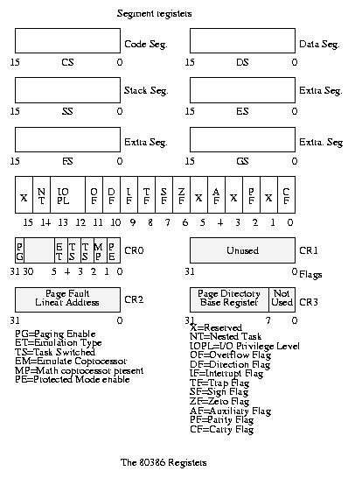
Understanding segments is the key to understanding protected mode. Protected mode segments have little in common with real-mode segments. A protected-mode segment register holds a 16-bit segment selector (see the figure below). Unlike in real mode, the selector has nothing to do with the segment's location in memory. Instead, the value in the register is an index into a table of segment descriptors. Each descriptor defines one segment and determines where the segment resides, the segment type, and other important parameters such as the access rights.
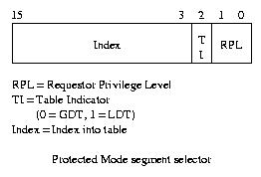
The selector contains three fields. The lowest two bits (RPL) pertain to the 386's protection mechanism which is explained shortly. The next bit, TI, determines which table of descriptors defines the segment.
There are three segment descriptor tables:
The Global Descriptor Table (GDT)
The Interrupt Descriptor Table (IDT)
The Local Descriptor Table (LDT)
Segment selectors never refer to the IDT. If TI is zero, the segment's definition is in the GDT. If it is one, the LDT contains the definition.

7.2 Tables Required in Protected Mode
Each descriptor table can hold upto 8192 descriptors. The INDEX bits (bits 15 through bit 3) in the selector determine which descriptor to use.
The GDTR and IDTR registers determine the location of the GDT and IDT respectively. Each contains a 32-bit address and a 16-bit limit. The limit is one less than the length of the table in bytes. The GDTR and IDTR are 48-bit registers. The address is linear rather than a segment-offset pair. Each table can contain upto 64KB or 8192 descriptors.
The GDT, as its name implies, is global; even when the system is multitasking, all tasks share the GDT. This is also true of the IDT - each task uses the same one. If one task changes the GDT or IDT, all tasks are affected.
The LDTR determines the location of the LDT. Unlike the GDT, each task usually has its own LDT. Unlike the GDTR, the LDTR does not contain a 48-bit address and limit. Instead, it holds a segment selector that must point to a special entry in the GDT. This GDT entry points to the LDT. The GDT may contain pointer to several LDTs.
The IDT is analogous to the real-mode interrupt vector table. Each descriptor defines the response to one of the 256 possible interrupts. Even though the IDT can contain upto 8192 descriptors, any more than 256 is a waste.
The figure below show the logical format of a basic descriptor table entry. Also, other special types of descriptors are also shown.

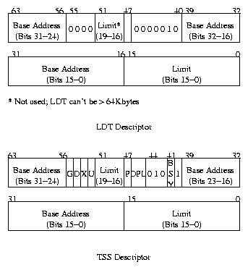
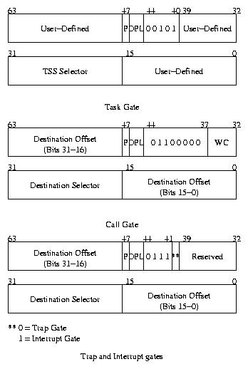

7.3 Descriptors
Two fields in the segment descriptor are particularly interesting. The P bit (bit 47) determines whether the segment is present. An operating system can clear this bit to create a virtual segment. When a program tries to use a virtual segment, the 386 generates an error. The operating system can then load the segment from the disk and try again. When P is clear, bits 0 through 39 and 48 through 63 can contain any values. The operating system could store a disk address here, for example. But this is unsuitable is the segment size is large. Fortunately, the 386 provides a better way to use virtual memory.
The other interesting field is the A bit (bit 40). The 386 sets this bit when any program writes to the segment. Our crude virtual memory system might use this bit to decide whether it should write a segment to disk before making it absent and reusing its space.
Another question is how a descriptor can specify a segment from one byte to 4GB long. The limit field given is only 20 bits. This is where the G bit (bit 55) comes into play. If G is zero, the limit field corresponds to one segment's maximum legal offset (one less than its length). If G is one, however, the 386 shifts the limit field 12 places left to make a 32-bit limit. The 386 fills the bottom 12-bits with ones.
For example

If a dscriptor has a limit field of one and G is one, the actual limit
is 1FFFH. When G is one and limit is zero, the limit is FFFFH.
This scheme allows us to specify a segment with a length of less than 1 Mbyte or a multiple of 4 Kbytes. When G is zero, the segment can range from one byte to 1 Mbyte long. When G is one, the segment can range from 4 Kbytes to 4 Gbytes in length (in 4 Kbytes steps).
It is possible to create two or more descriptors that point to the same area of memory. An operating system, for example, might load a file into a data segment and jump to a code segment that starts in the same place. This process is known as aliasing. The operating system must have some way of loading the GDT and other tables. Therefore, it will usually have a data segment alias to the GDT. Some systems set up a data segment that covers all 4GB of memory. Tables can then be written directly with that data sgement. Operating systems rarely allow user programs to access the GDT, IDT and other system tables directly.
The processor reserves the first slot of the GDT. The selector for this slot is the null selector, and using it always causes an error. The null selector's descriptors should be all zeros. Non-zero values work but you never know ;-).

8 Protected Mode Privileges
Protected mode gets its name from the 386's privilege protection. Each program has a privilege level, or PL, from zero to three. Programs at PL0 can execute any instruction and access any data. Programs at PL3 can't execute certain instructions; they also can't access data that belong to more privileged programs. Each segment descriptor has a Descriptor Privilege Level (DPL) that the 386 uses for protection. The 386 also controls which programs can execute I/O instructions.
A privilege hierarchy is important for supporting modern operating systems. In a typical operating system, the main kernel runs at PL0. Other parts of the operating system might run at PL1. Device drivers can run at PL2; they need to do direct device I/O. User programs in this system would run at PL3. This scheme has many advantages. In particular, a malicious program can't damage the operating system or other user programs.
PL0 programs alone can execute the following instructions:

•HLT
•CLTS
•LGDT
•LIDT
•LLDT
•LTR
•LMSW
•MOV (to/from control/debug/test registers)

The IOPL field in the EFLAGS register allows the operating system to control who can do I/O. These two bits determine the minimum privilege level a program must have to execute I/O instructions (CLI, STI, IN, INS, OUT and OUTS). If IOPL is zero, only PL0 programs can do I/O. If IOPL is 3, all programs can execute I/O instructions. Only a PL0 program can modify the IOPL flags. When other programs modify the flags, IOPL doesn't change! Leaving IOPL=3 makes life easy for DOS Extenders, but it can cause major problems since real-mode programs mostly use direct I/O.
A program's privilege level is equal to the RPL field of the selector in the CS register. This is the current privilege level or CPL. You can't directly modify the CS register so that it has a different RPL. The same holds true for SS as well.
8.1 Data Access
Programs can't load a sgement register with just any selector. When a data segment register (DS, ES, FS or GS) is loaded, the 386 checks the DPL against the program's CPL and the selector's RPL. The 386 first compares the CPL to the RPL. The largest one becomes the effective privilege level (EPL). If the DPL is greater than ot equal to the EPL, the 386 loads the sgment register; otherwise an error occurs.
The SS register must be loaded with a segment whose DPL and CPL are equal. The 386 also checks to make sure a stack segment is readable, writeable and present.
The 386 provides a special stack segment type. You can also use a plain data segment for a stack, if you wish. A stack segment's limit field indicates the lowest legal offset in the segment.
It is always valid to load a null selector (0 through 3) into a segment register. However, any attempt to access memory via the selector will cause an error as expected.

